STG call 30/10

**Progress update on the simulation model for the Pacific hake MSE**

**Overview of the MSE simulation modelprocess**

Management strategy evaluation (MSE) investigates the performance of management procedures in the face of uncertainty (Figure 1). Our Modeling an MSE model can be divided into four partsfunctional components: 1) an operating model (OM) that simulates the underlying dynamics of a population and the fisheries 2) data generation from the OM, 3) an estimation model (EM) performs a stock assessment based on the data generation, 4) a harvest control rule is applied based on the output from the stock assessment. Finally, the process is repeated and the operating model is updated for the following year based on the catches specified by the harvest control rule.

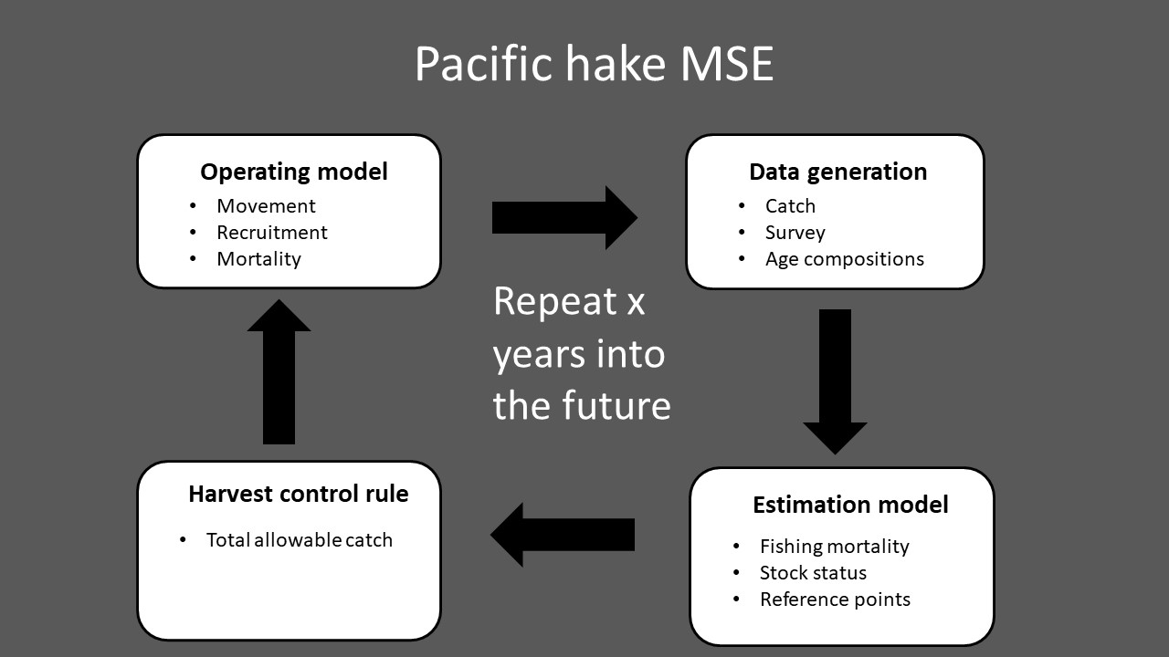

Figure 1: Conceptual overview of the Pacific hake management strategy evaluation (MSE).

**Progress on model development and testing**

* Estimation model testing and improvements
  + Code debugged and tested
  + Fixed previous issues with estimation model not converging and not being able to estimate uncertainty (non-identifiable Hessian)
* Operating model testing and improvements
  + Added option to explore future scenarios with simplified catch metrics, enabling quick sensitivity analysis of OM parameter assumptions
  + Added option to “turn-off” movement for sensitivity analysis and comparison to previous coastwide MSE simulation model
  + Added parametric function to describe how movement changes with fish age (Figure 2). This will allow faster sensitivity testing to assumptions about movement rates by reducing the number of parameters describing movement.
* Completed code to conduct full closed loop simulation
  + Completed code to calculate performance metrics as defined by JMC
  + Ran initial projections (see Figure 3 for examples)
  + One 50 year projection takes approximately 5 minutes

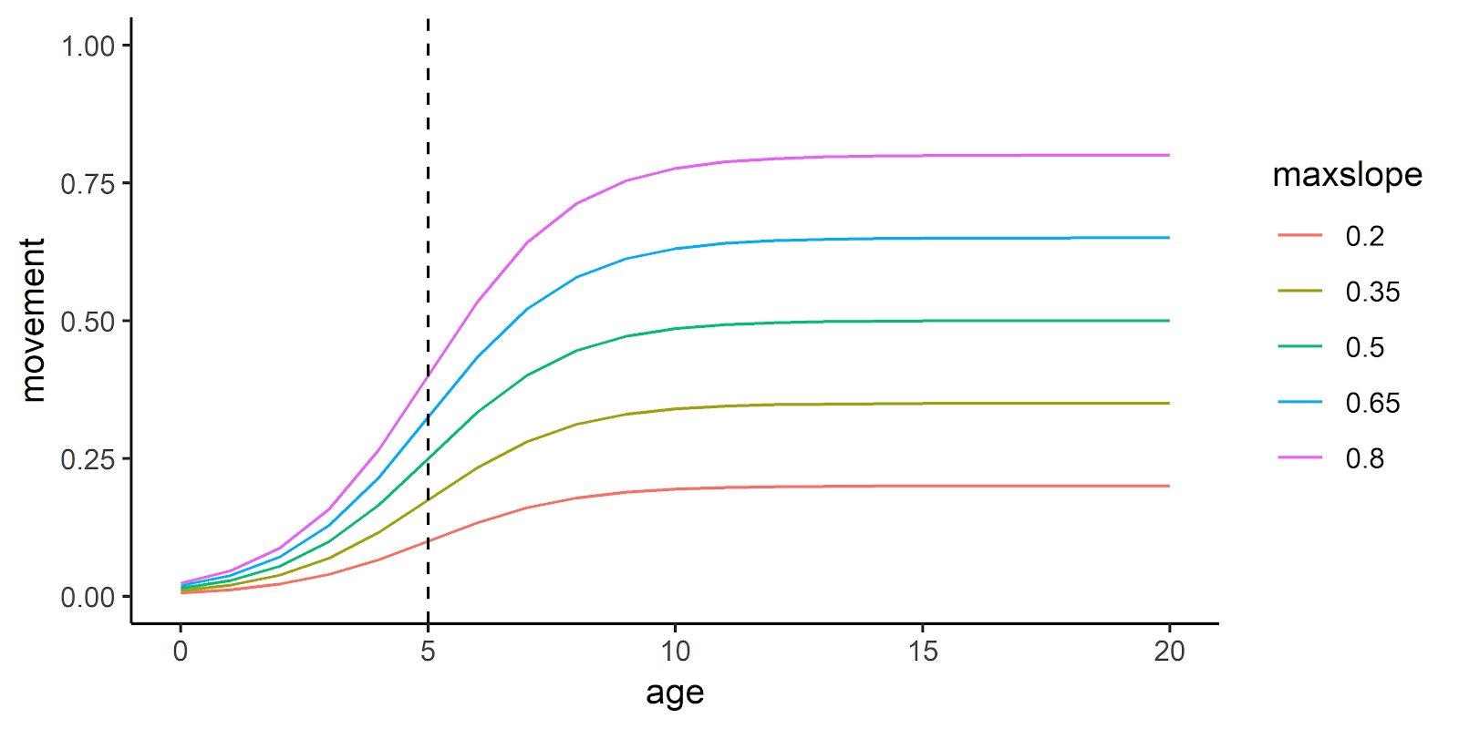

Figure 2: Examples of movement in the operating model. Colored lines denote max movement rate, and vertical dashed line denotes the age at 50% of maximum movement rate.

**Datasets currently used for model conditioning**

* Fisheries independent Bi-annual survey index of abundance. Spatially explicit (starting in year 1995).
* Fisheries independent survey age compositions in Canada and the US in survey years (Figure 4)
* Fisheries catch in Canada and the US
* Fisheries age composition in Canada and the US

**Planned activities before SRG meeting in February:**

* Perform simulations with varying movement parameters within the MSE framework
* Compare performance metrics in the MSE with movement enabled/disabled
* Investigate sensitivity of performance metrics to movement parameters

**Discussion questions:**

* Which simulations should be prioritized for the December/February meetings (e.g., a range of movement rates, harvest strategies or recruitment scenarios)?
* Are the movement assumptions reasonable?
* Suggestions for OM conditioning and future simulations?

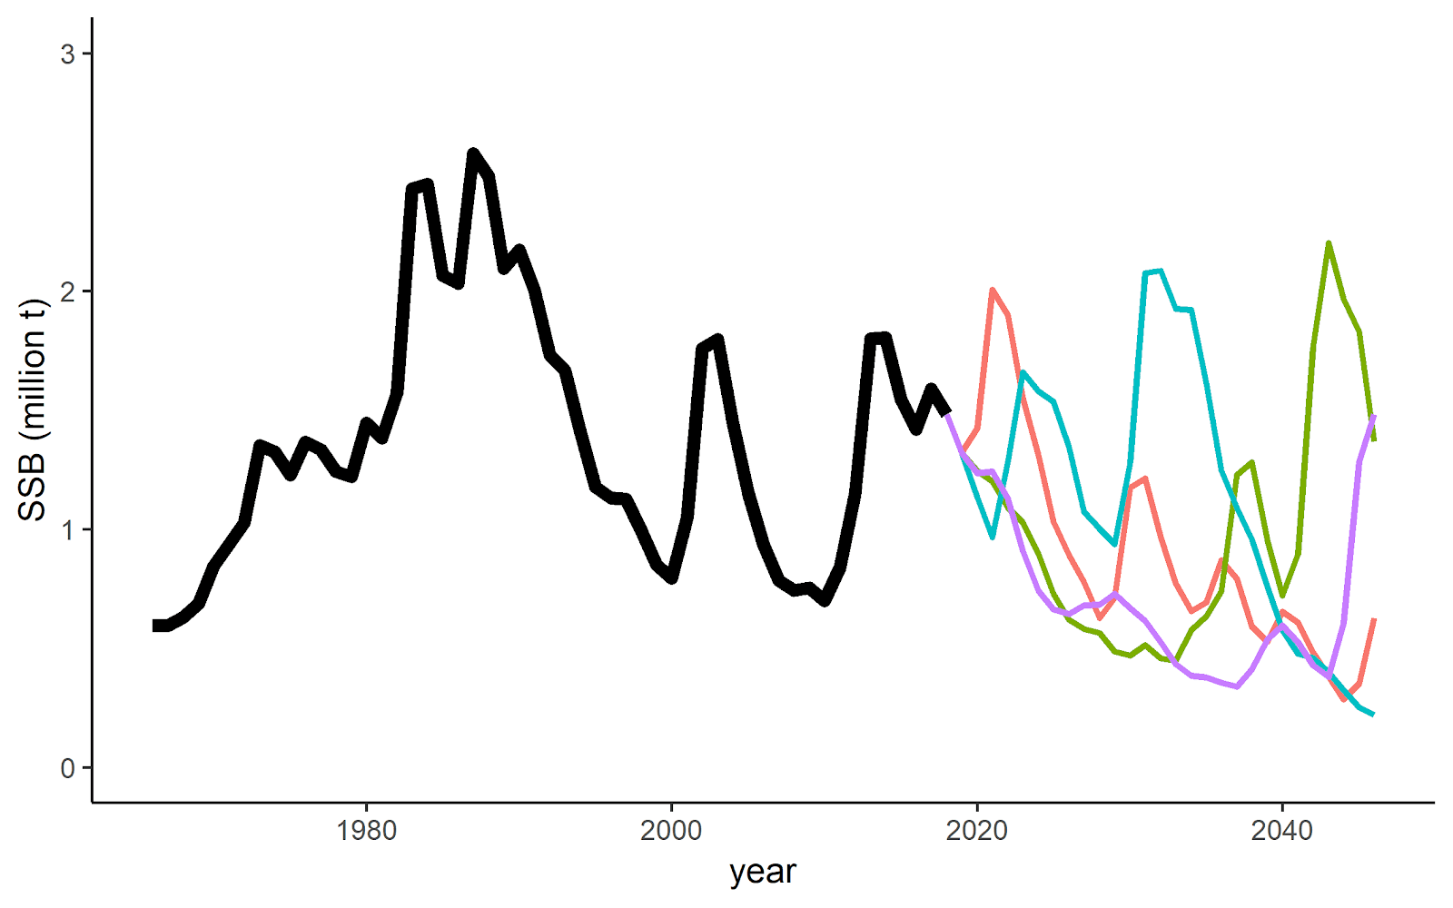

Figure 3: Spaghetti plot of four example MSE iterationsprojections, assuming full utilization of the total allowable catch, and . Mmaximum movement rate of is 0.5.

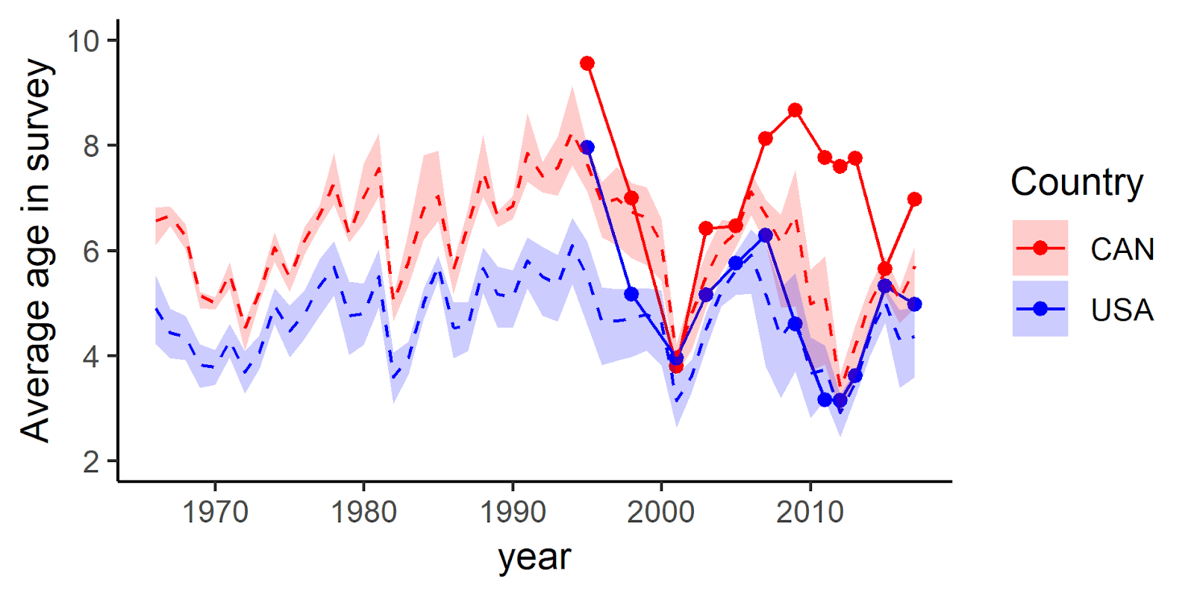

Figure 4: Average age from the fisheries independent survey. Dashed line indicate mean output from the operating models using the maximum movement rates from figure 2. Shaded area indicate the minimum and maximum values. Solid dotted lines are data from the survey.

**Planned activities Things to do before SRG meeting in FebruaryDecember:**

* Perform simulations with varying movement parameters within the MSE framework
* Compare performance metrics in the MSE with movement enabled
* Investigate sensitivity of performance metrics to movement parameters

**Discussion questions:**

* Which set of simulations should be prioritized for the December/February meeting (e.g., a range of movement rates, harvest strategies or recruitment scenarios).
* Are the movement assumptions reasonable?
* What can we do to improve OM conditioning?
* Other ideas for simulation and OM structuring?

Appendix: Reminder of MSE objectives and operating model assumptions, as presented to JMC in August

**MSE objectives**

* Evaluate how spatial processes influences the biology and the management of Pacific hake
* Investigate potential climate change consequences to the fishery and management system
* Evaluate the assessment model under different ecological realities

**Operating model**

The core of the operating model is a standard age based model with a latitudinal spatial structure. The model has been implemented as flexible software to investigate a range of potential operating model configurations, such as number of spatial grid cells, timescale, temporal movement, and spatial and time varying selectivity. Initial model runs have been explored based on few core assumptions listed below:

* Timescale: initial years (1965-2018) + 35 years into the future. Runs 4 seasons per year. Recruitment occurs in season 1.
* Current spatial structure assumptions:
  + 2 boxes
  + Initial distribution of 75% percent of the stock in the southern area and 25% in the northern area.
  + Stock-recruitment is area dependent, but has the same productivity parameters
* Generates fishery data every year (total catch and age compositions), survey data every second year in the future (survey index of abundance and age compositions)
* Age based movement parameters each season
  + Recruits and 1 year olds do not move
  + Movement rate is modeled as the fraction of the numbers at age that leave an area
  + Movement rates are modeled as a logistic function of age with 3 parameters (maximum movement rate, slope of movement rate and the age at 50% of maximum movement) (Figure 3).
  + Most spawning individuals migrate south and spawn in the last season of the year
  + During the year, fish rarely move south.
* One “fleet” in each area (country) and Ggear selectivity is constant within each area, but with possibility to be time varying

* Software designed to be flexible to allow multiple operating model configurations to capture a range of possible dynamics of the population and the fishery. Operating model runs in the R environment.

**Summary of current state of the MSE closed loop simulations:**

* Fully operational closed loop
* First iteration of operating model
* Flexible OM and EM allowing for comprehensive sensitivity analysis of parameters and assumptions
* New software implementation allows much faster (greater than 10x) running time than MSE approach used in the past, in spite of the additional complexity in the spatial and seasonal Operating Model.